**Supplementary Materials** for:

Optimising an evolutionary experiment to evolve nitrogen-fixing legume symbiosis in *Mesorhizobium australicum* BR1-1-5xICE*Ml*Sym

**Nodulation Assessment Photographs**

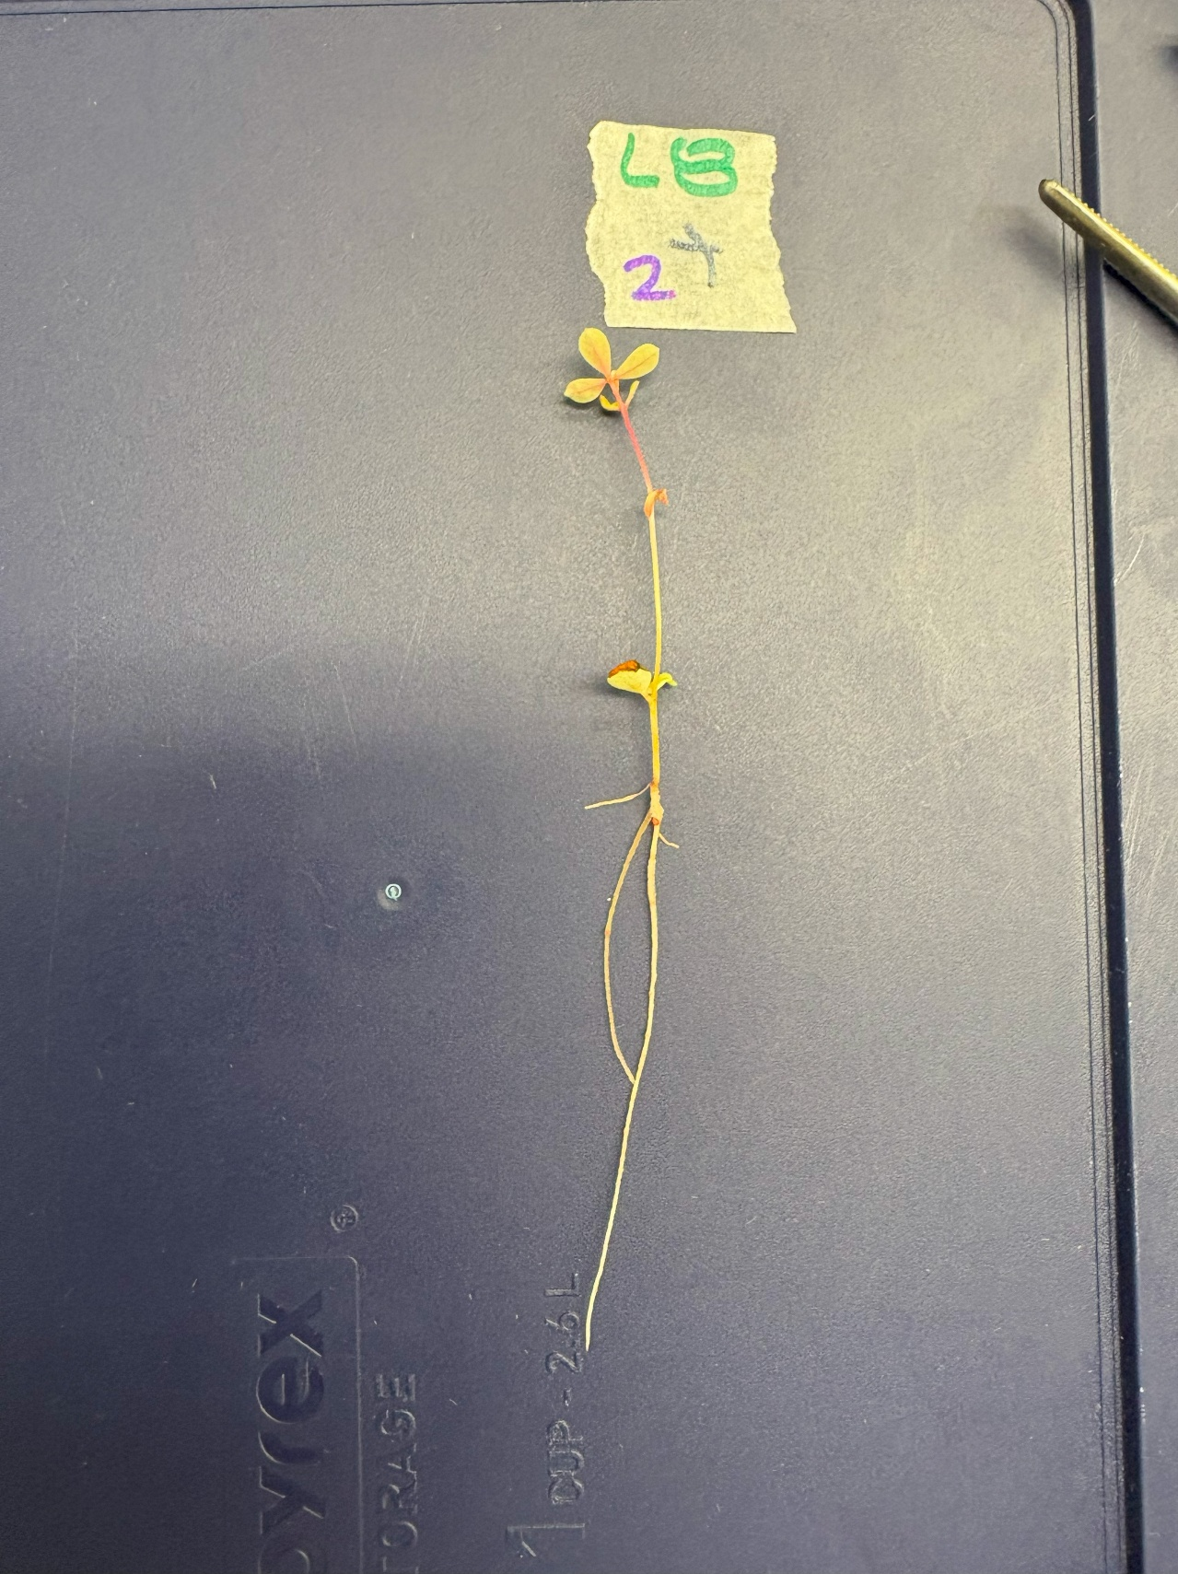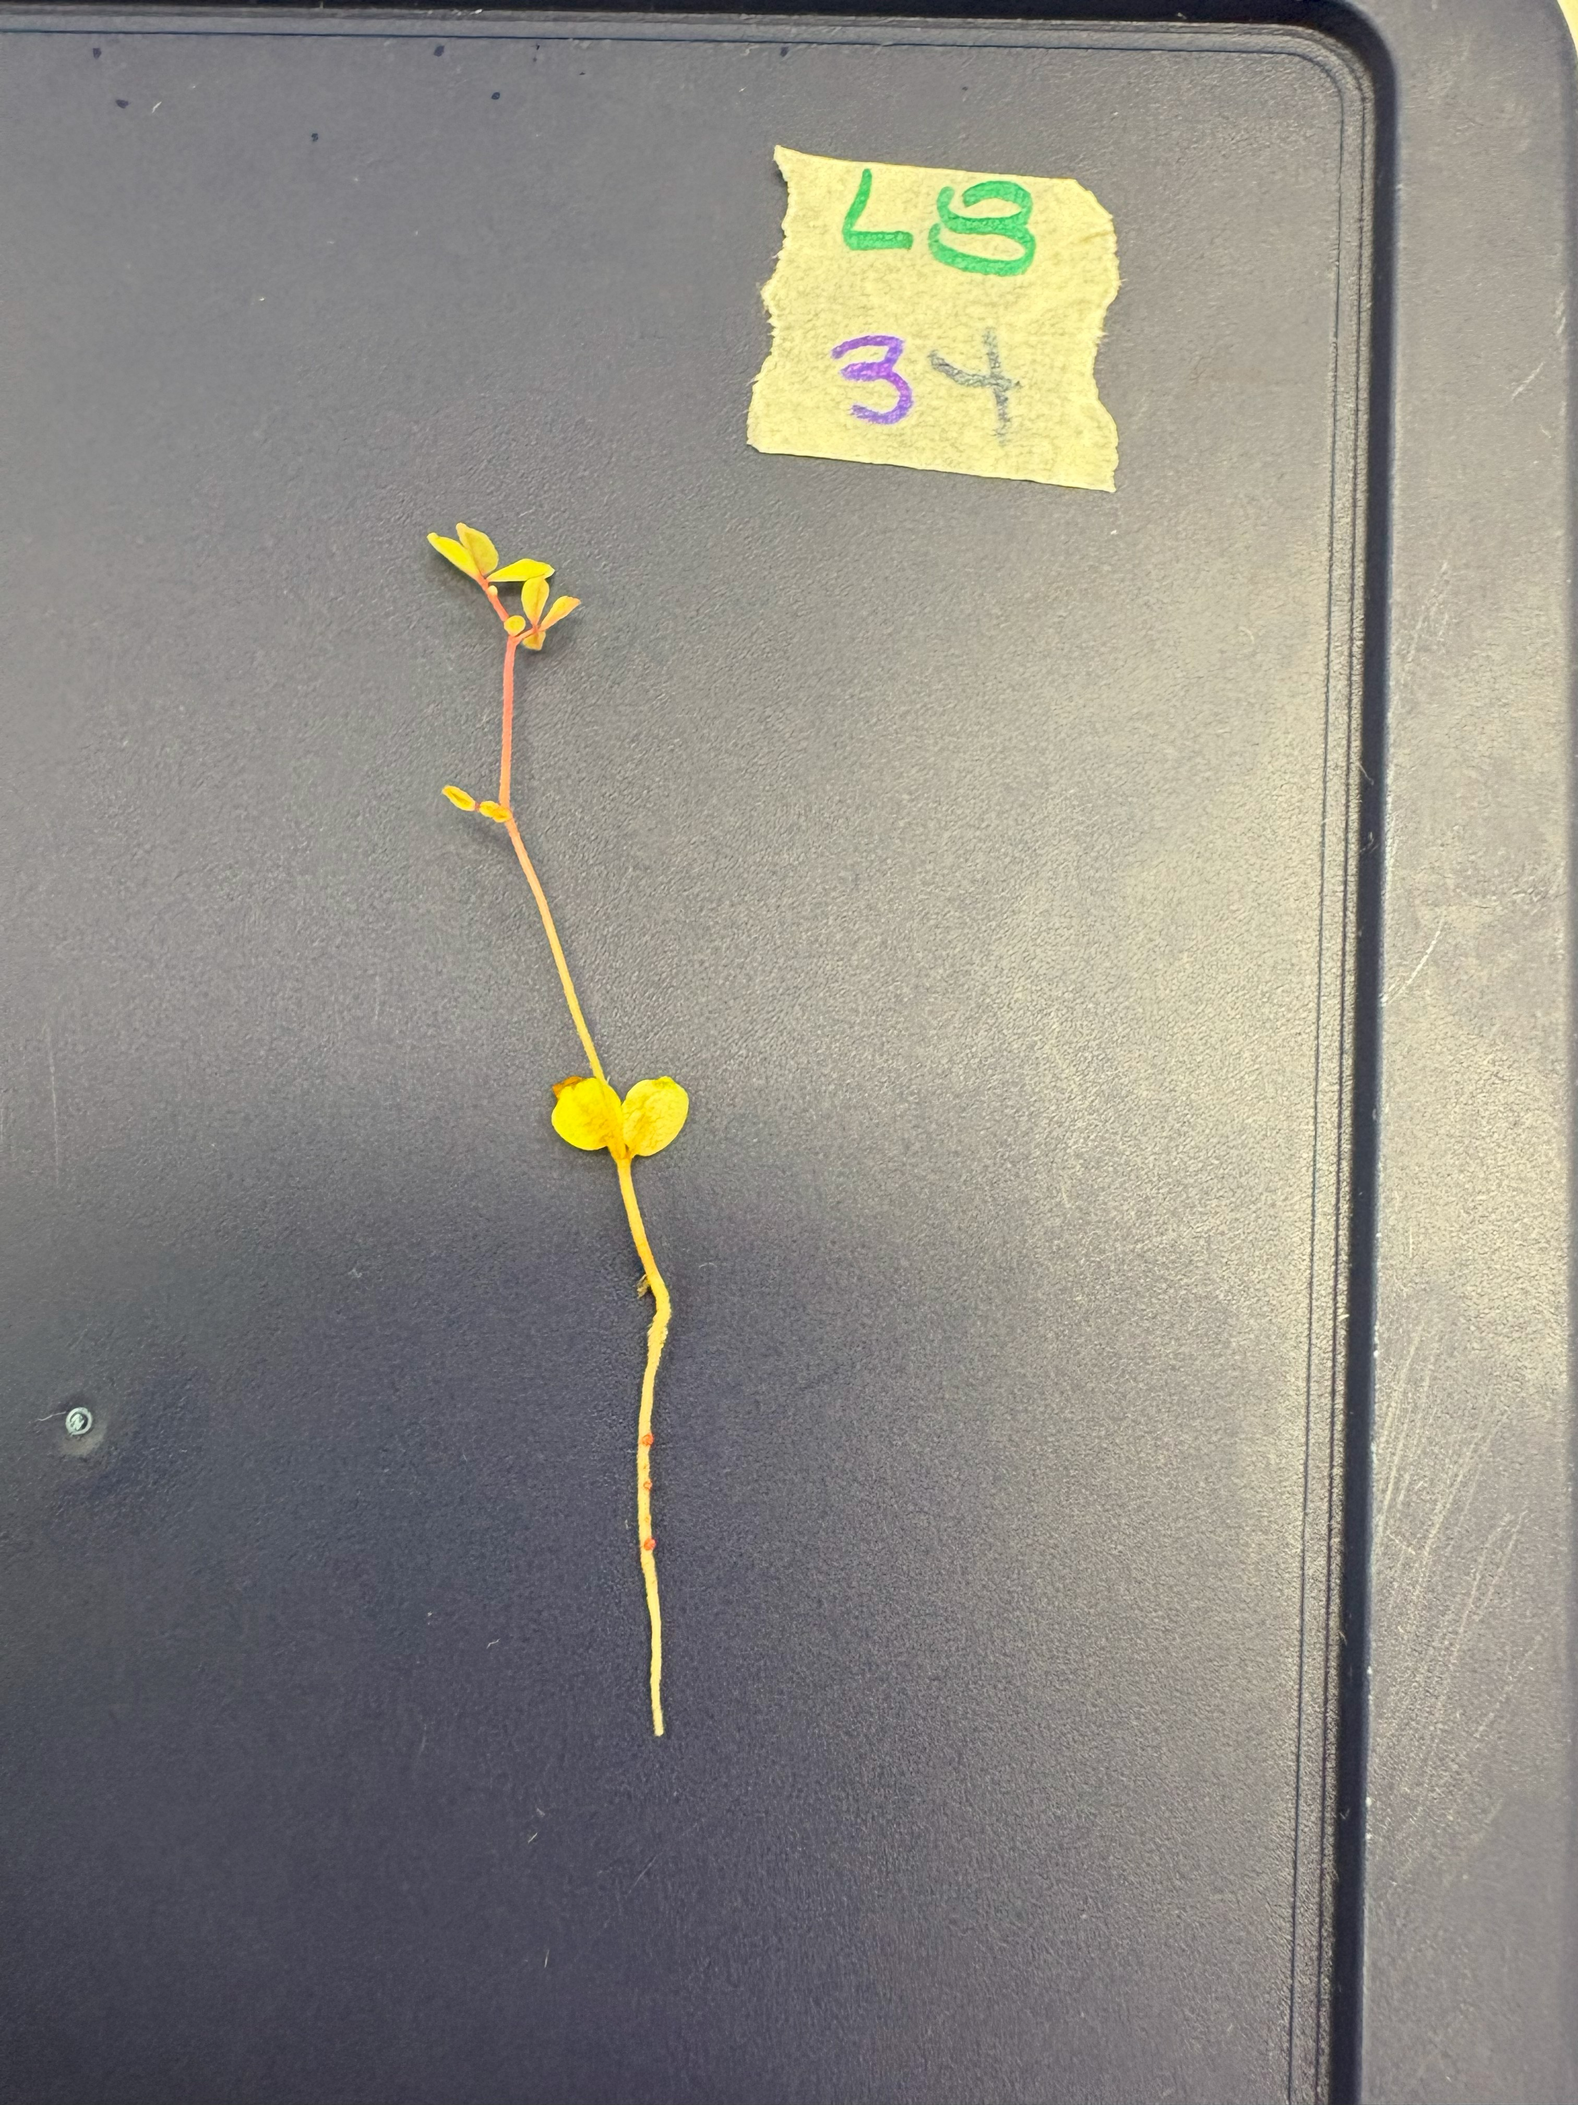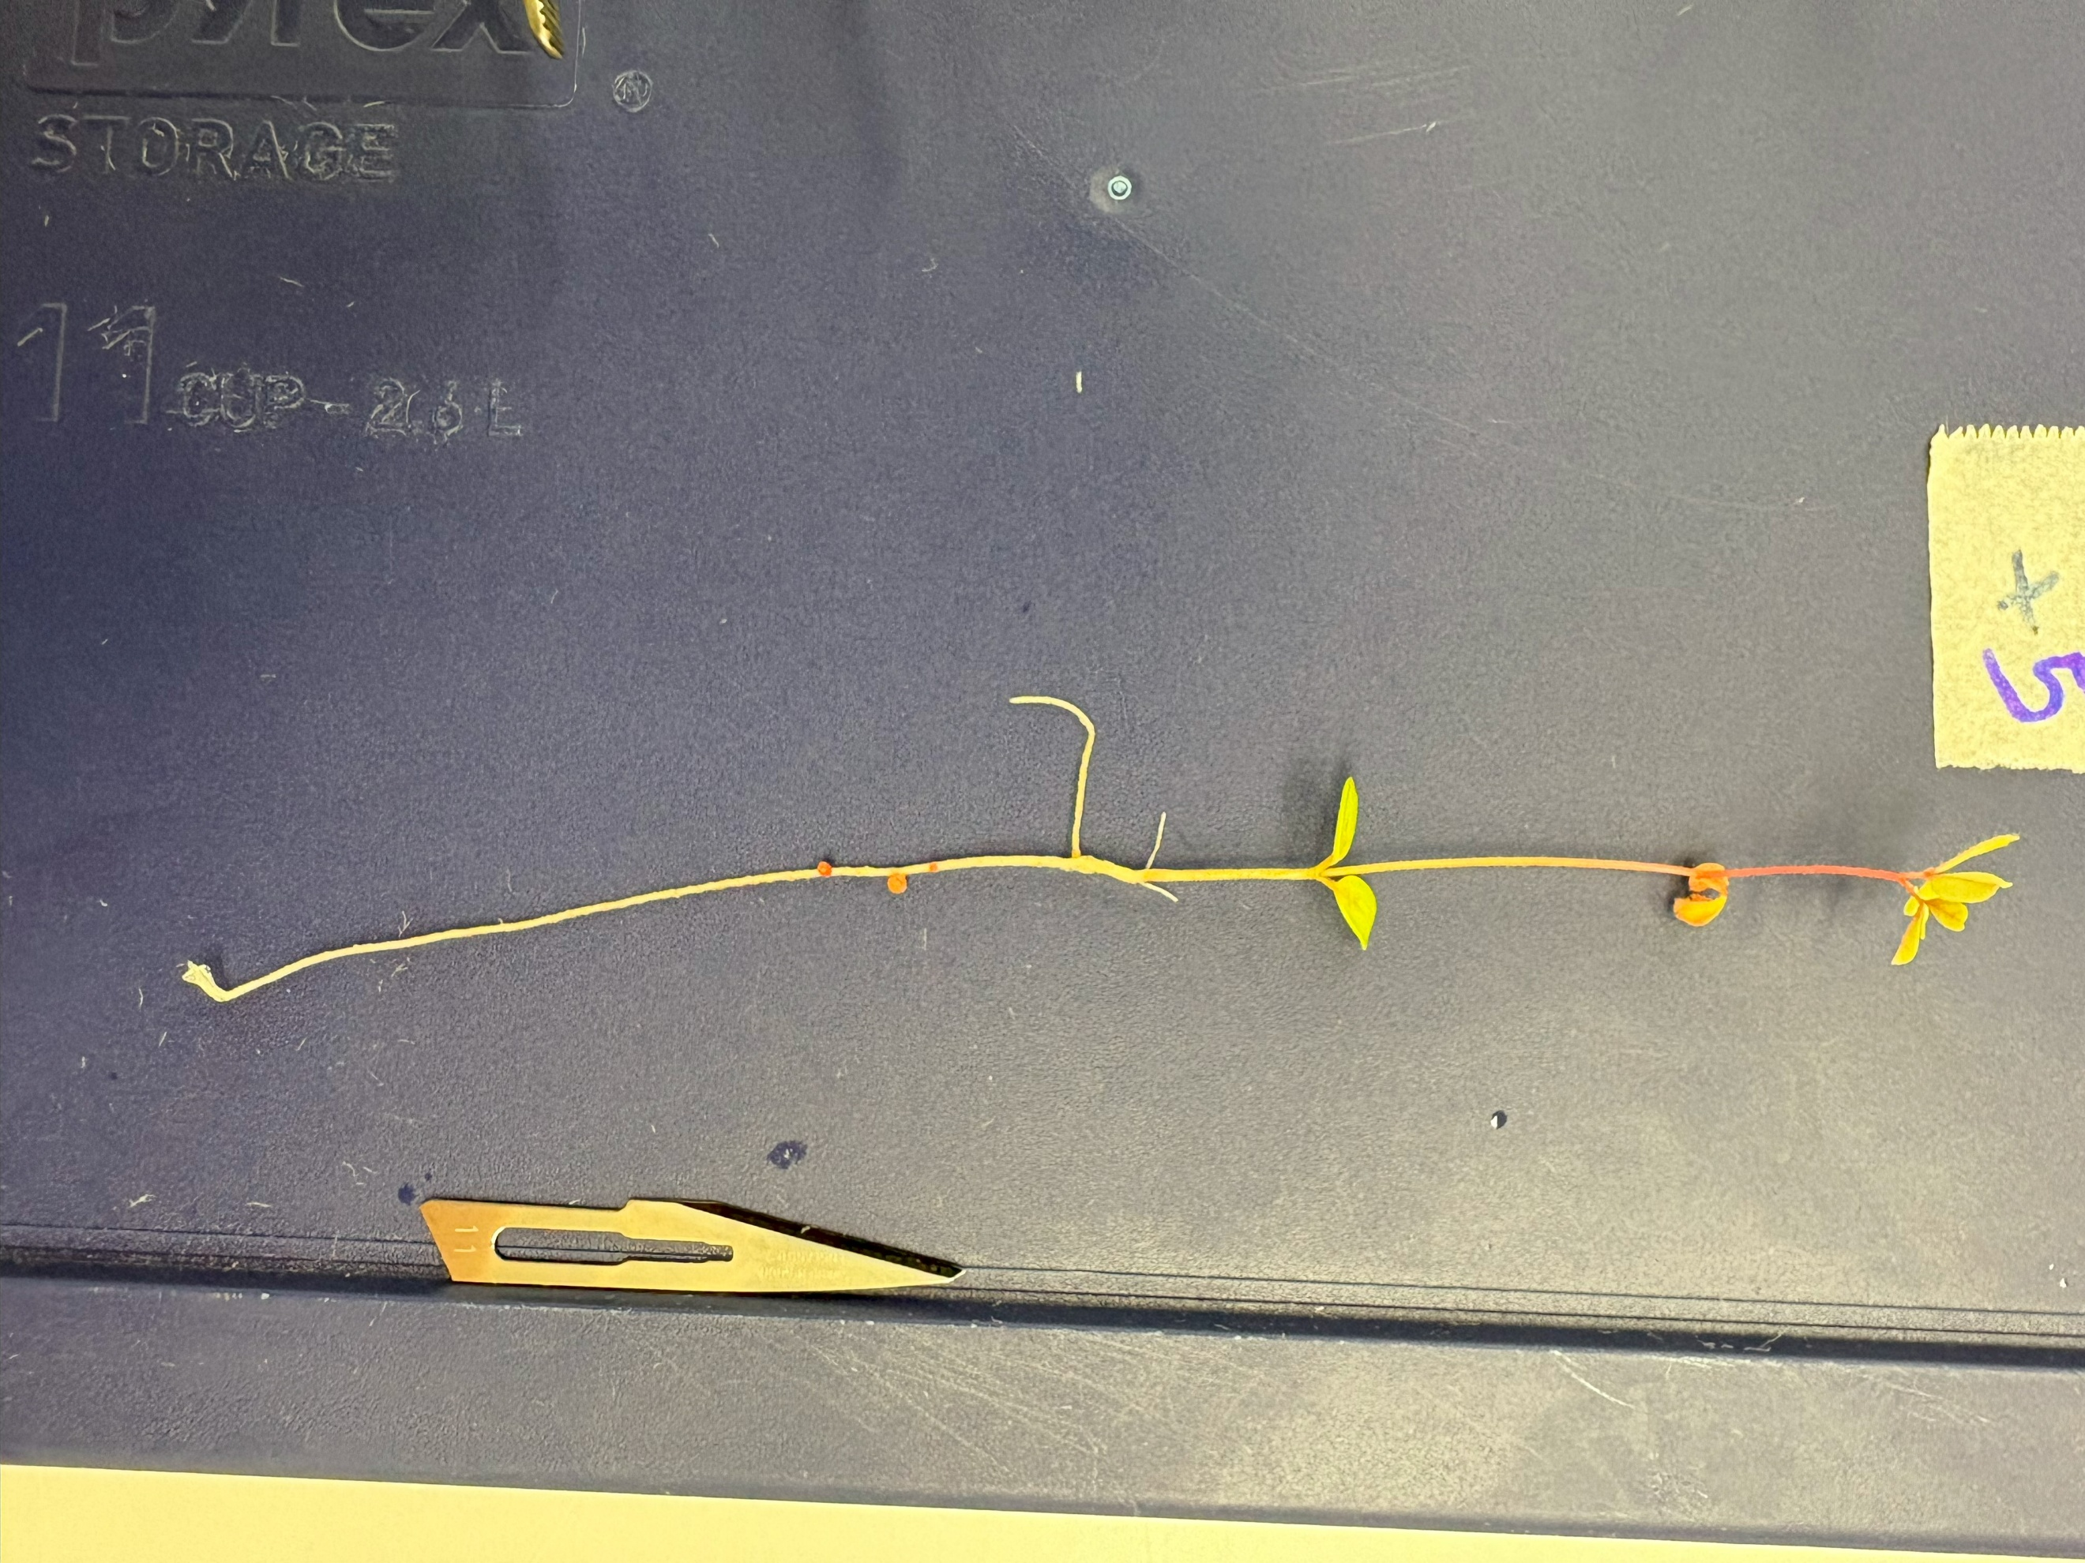

**Supplementary Fig 1.** *L. rectus* Tas2206 nodule-presenting subjects (from left to right: L8+2, L8+3, L8+5). Note the red-coloured nodules present on the roots of each subject

**Supplementary Fig 2.** *L. australis* ID#3 nodule-presenting subjects (from left to right: L4+1, L4+6, L4+7). Unfortunately, due to resting position of the plant, lighting, and the absence of red pigment, the nodules are difficult to observe in these photographs. As such, the nodules have been highlighted for convenience.

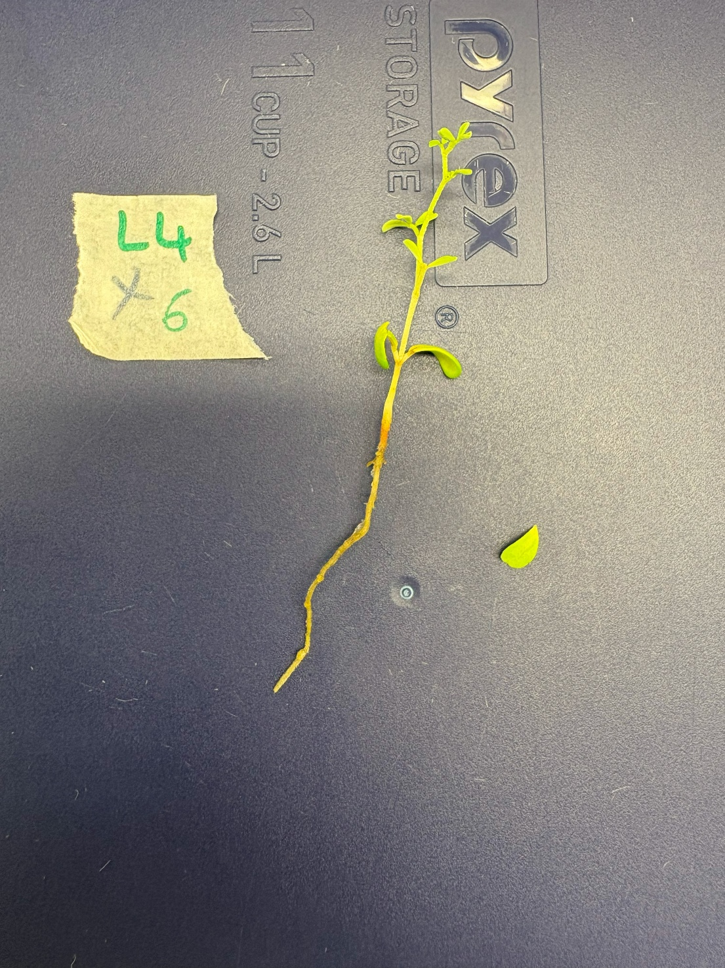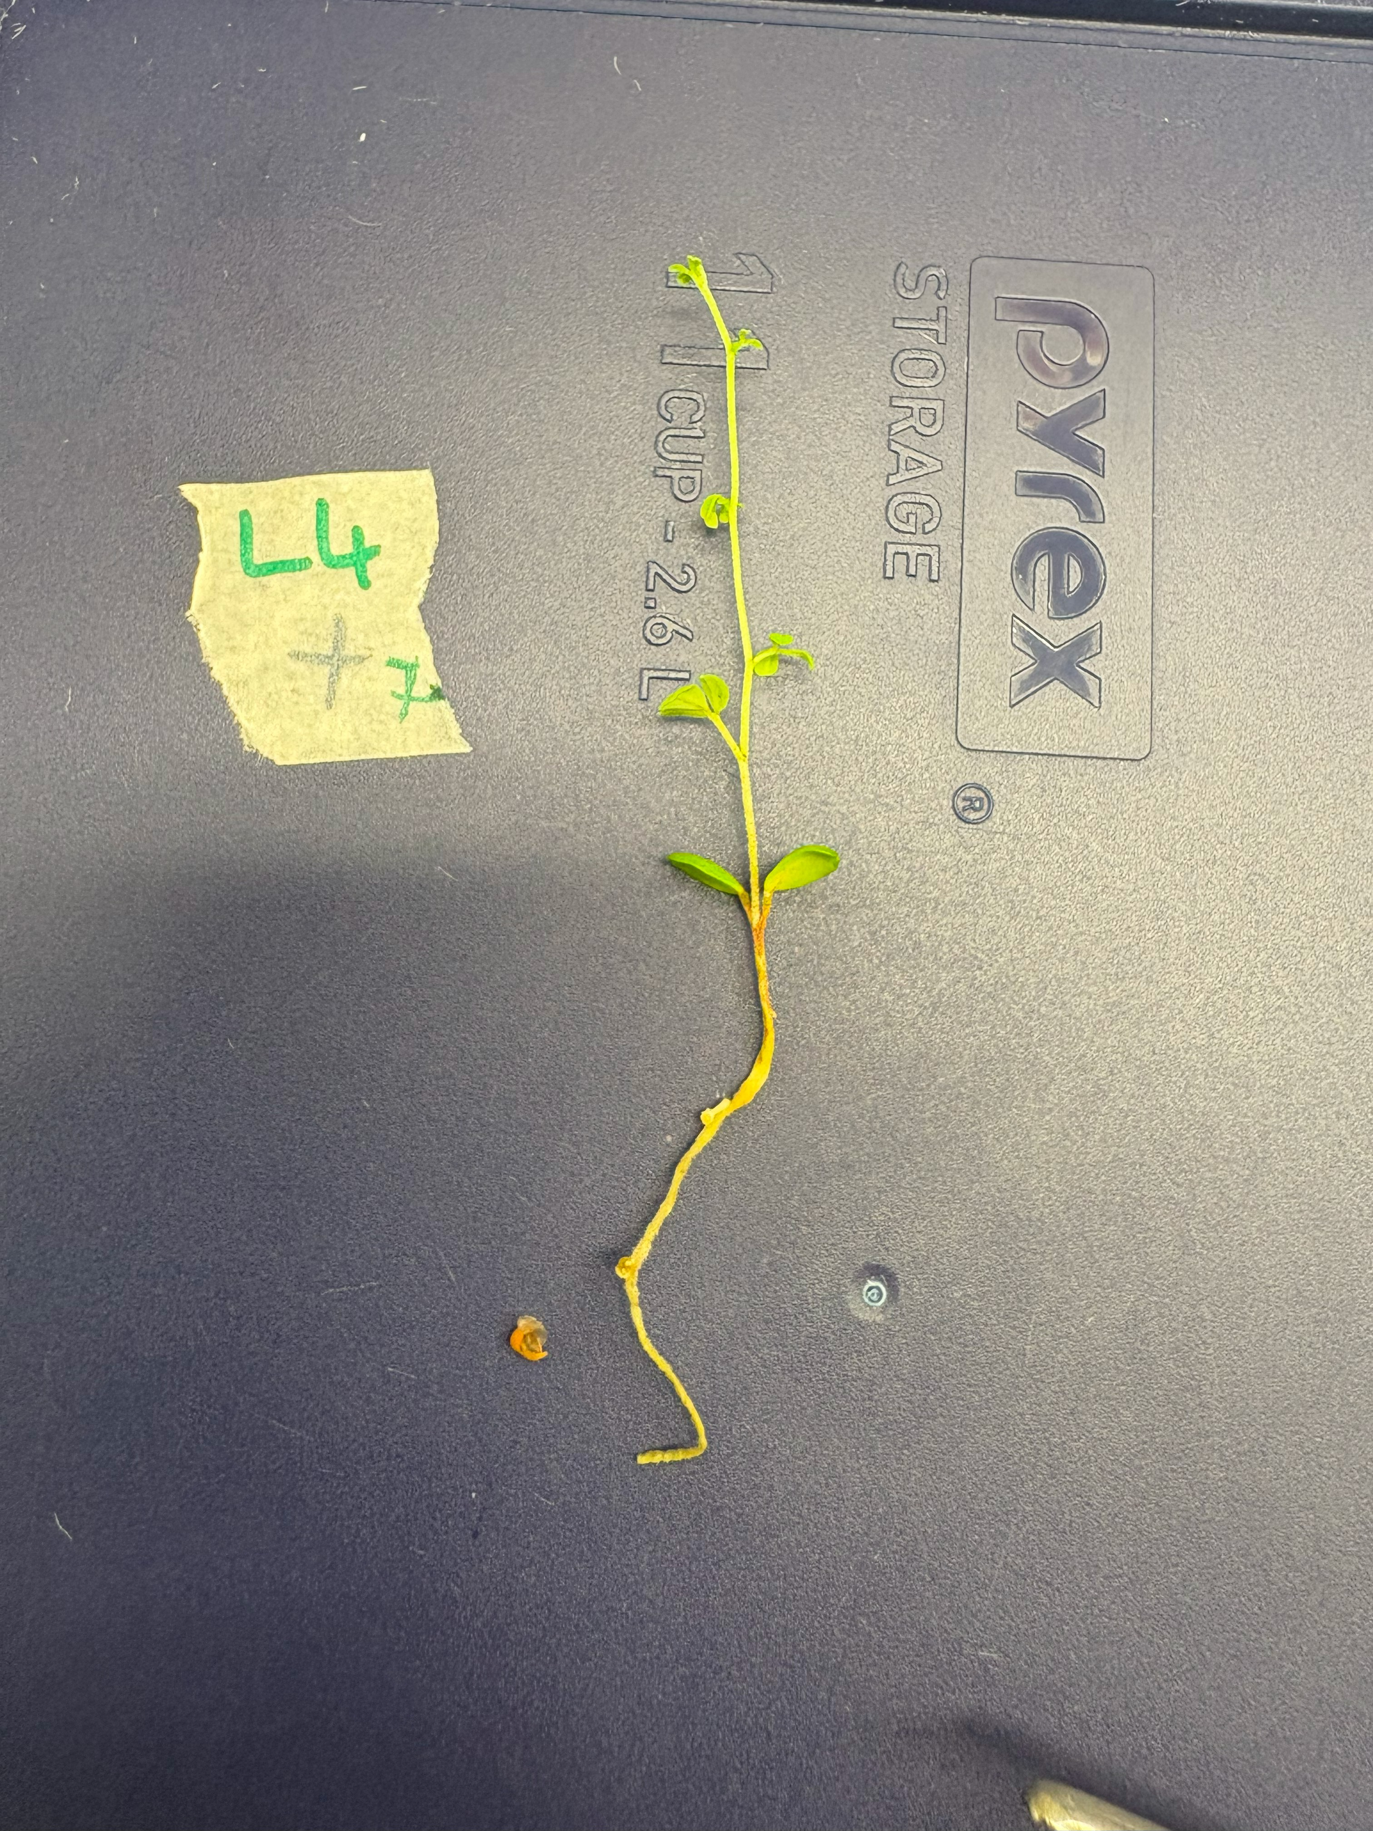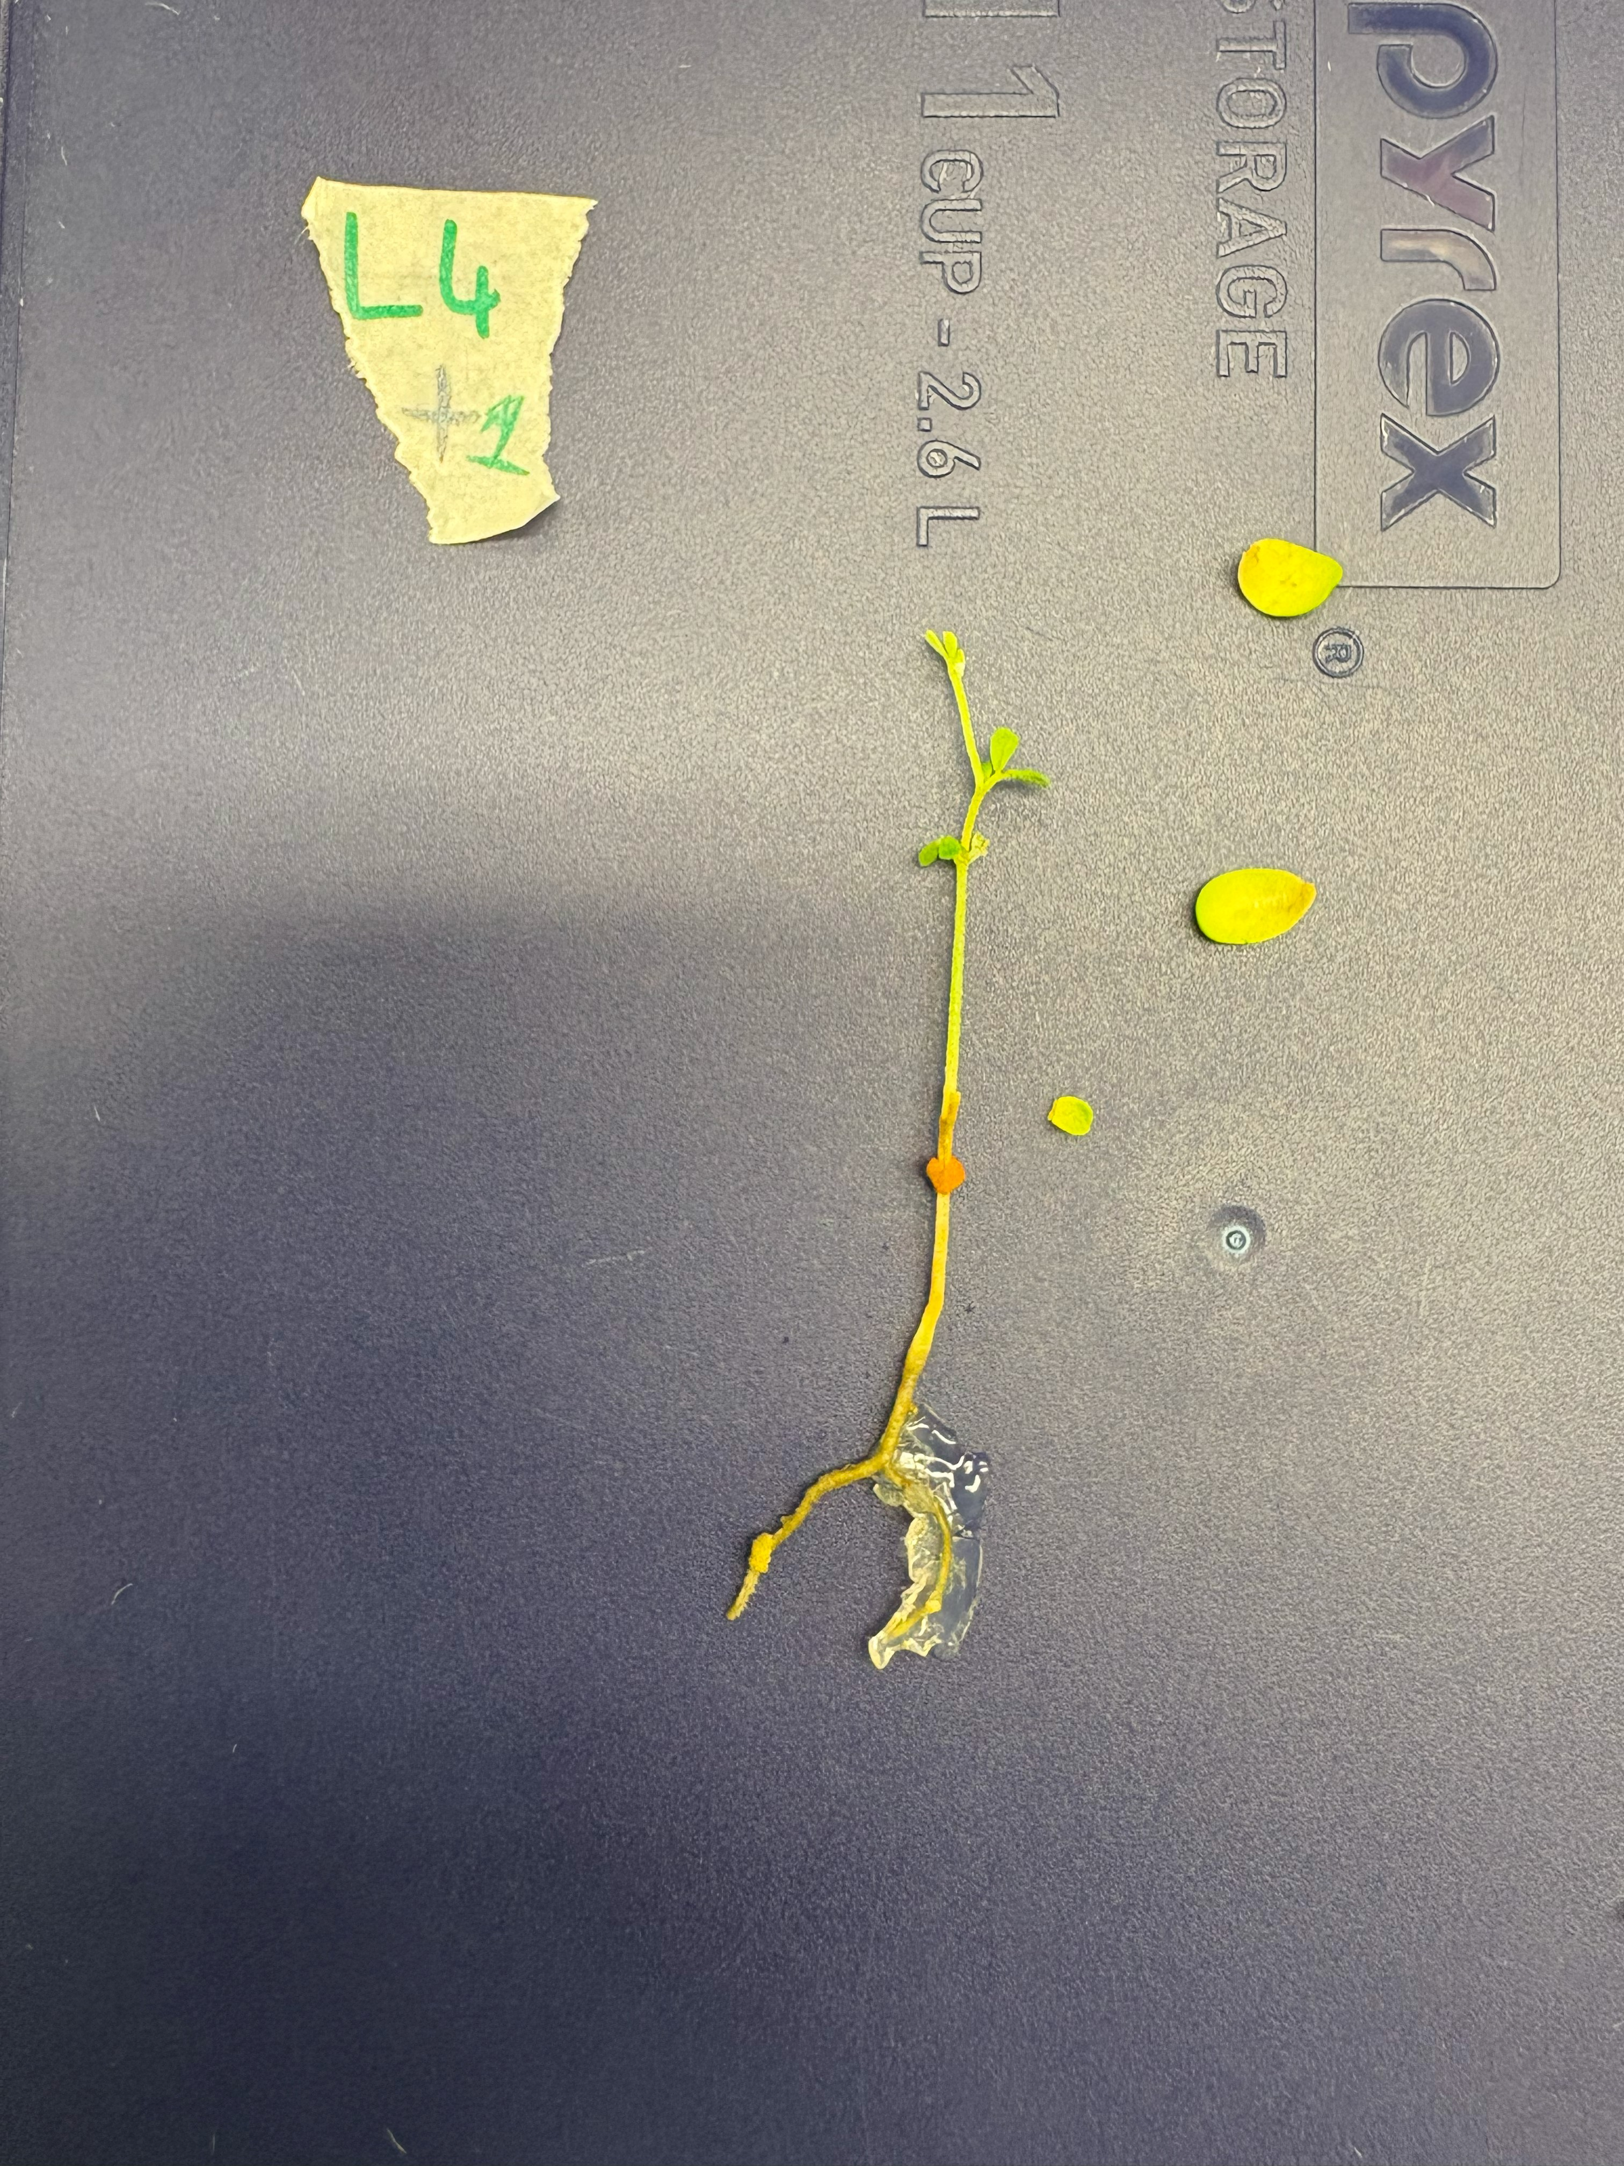

**Supplementary Figure 3a.** *L. uliginosus* GLOC005 bump-presenting subjects (left: L7+2, right: L7+3).

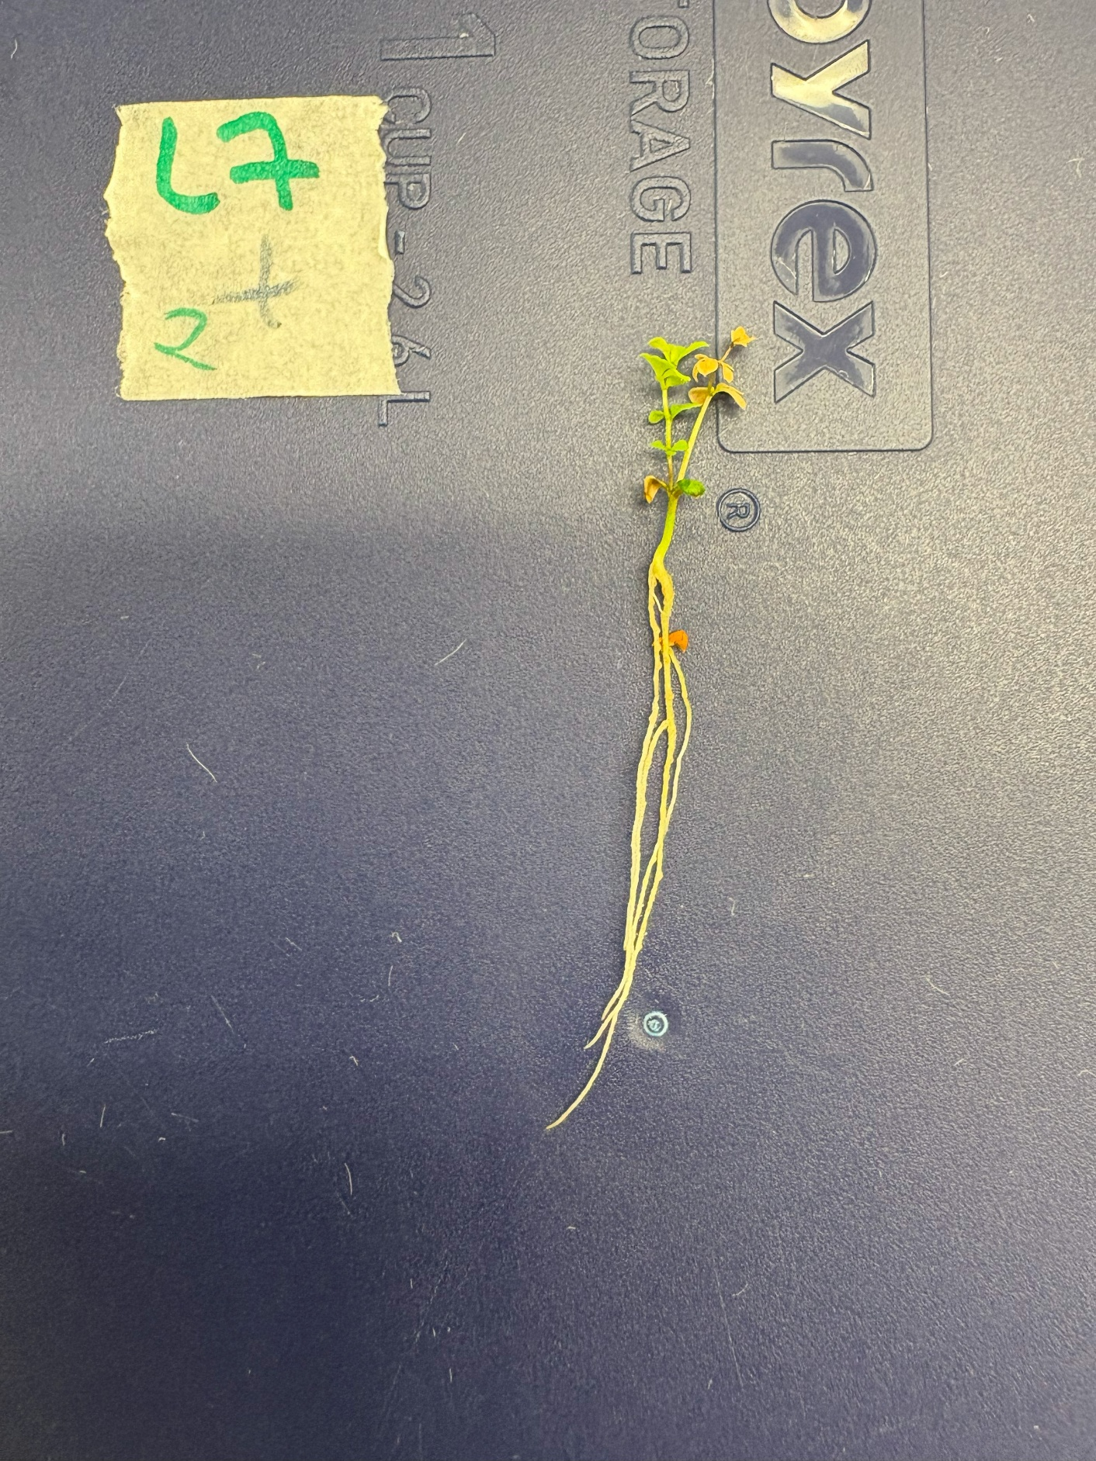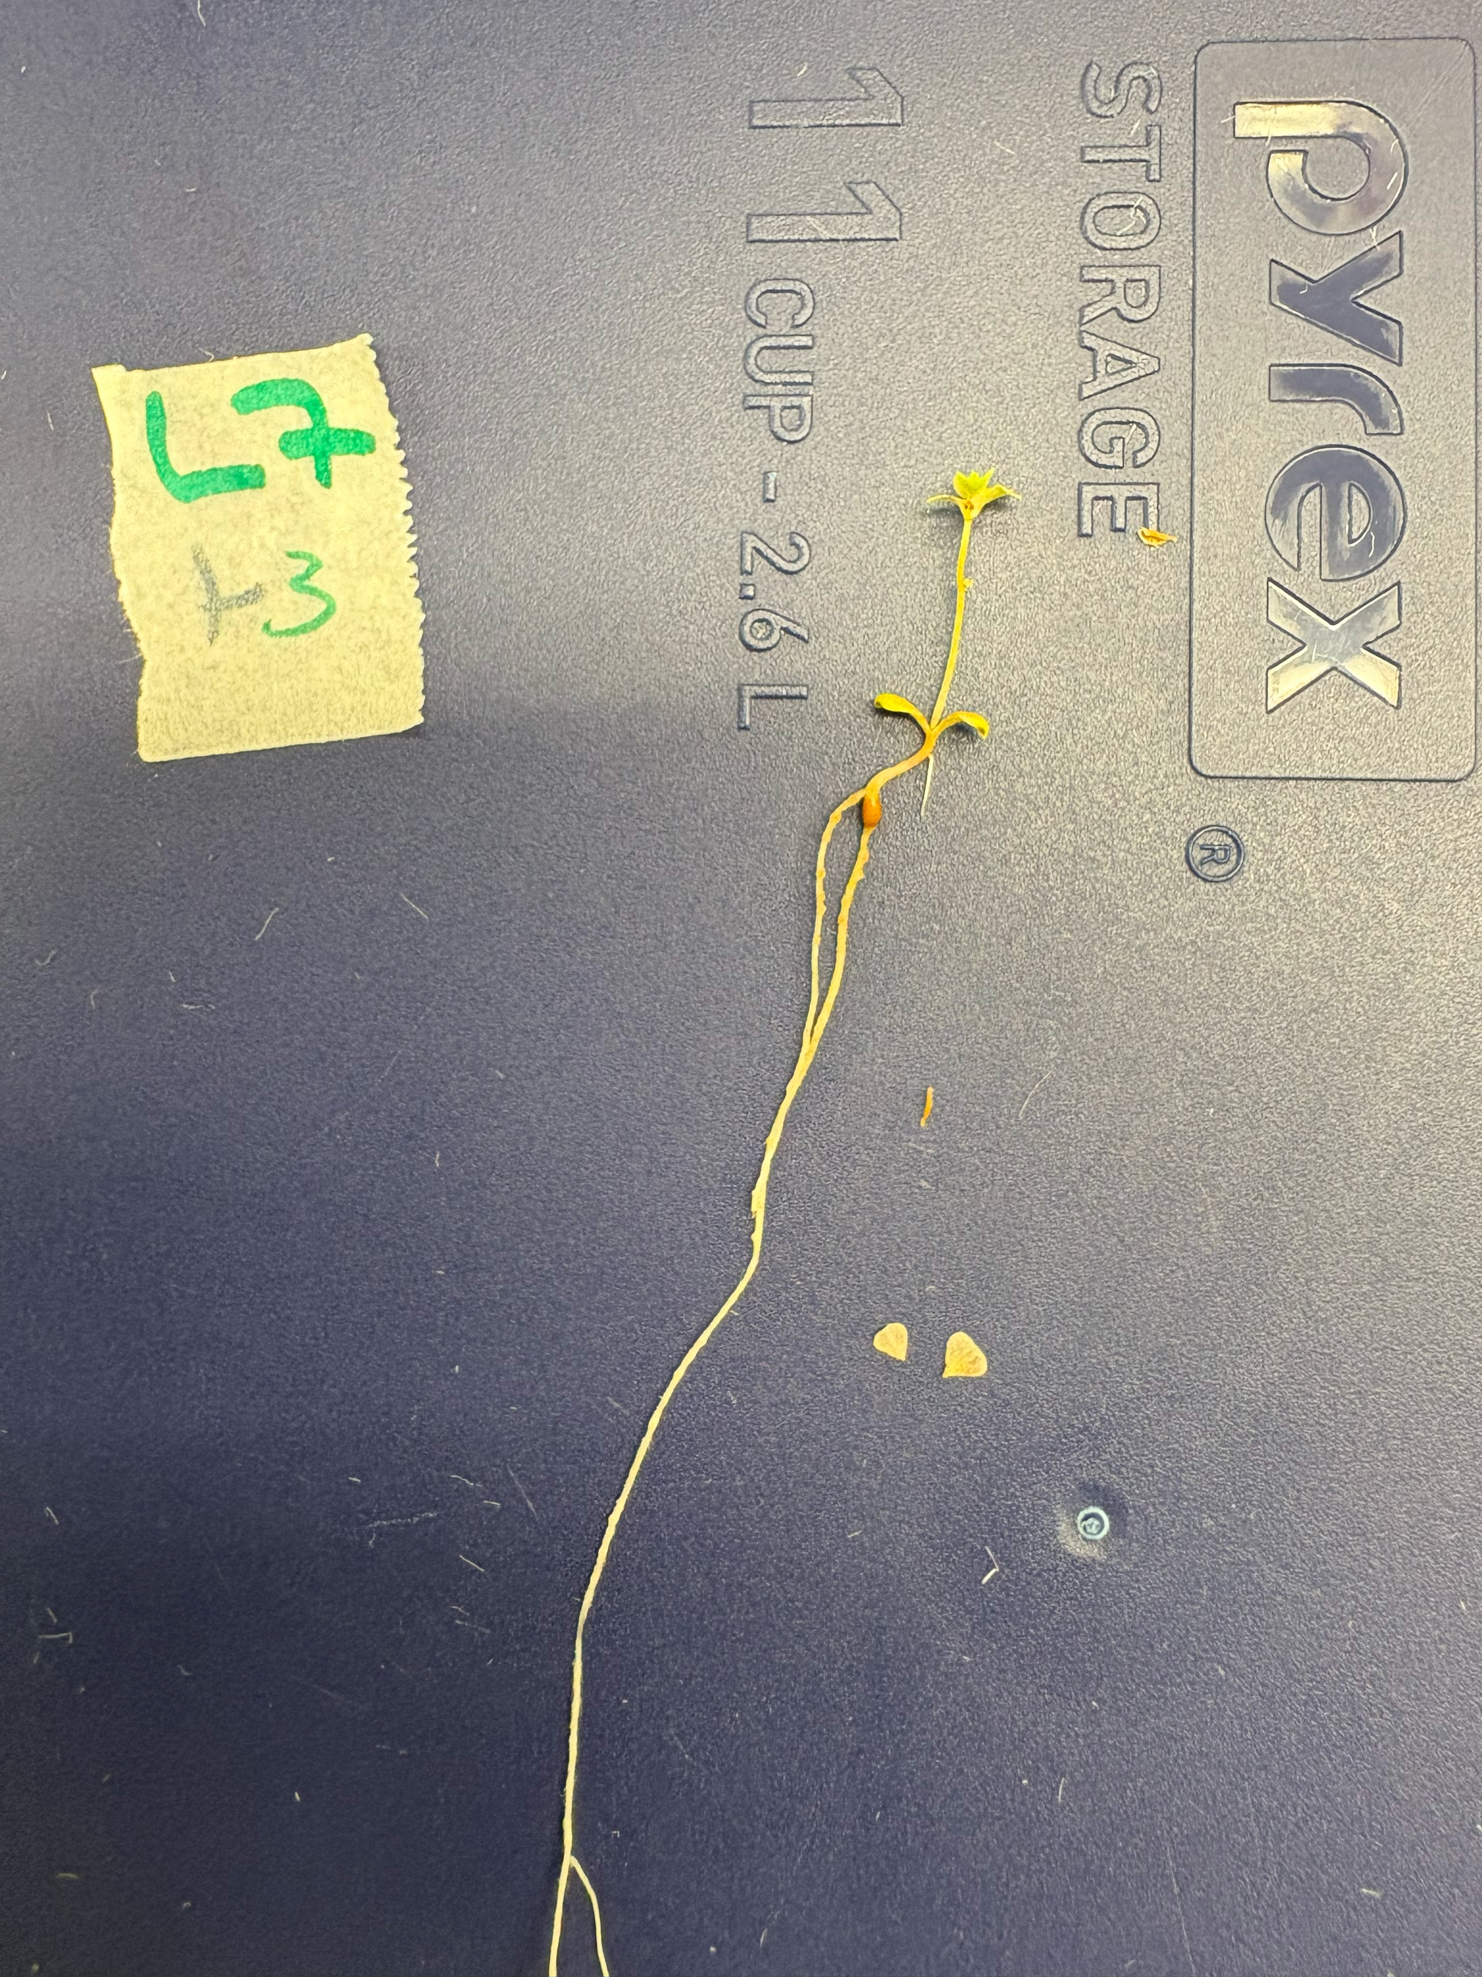

**Supplementary Figure 3b.** *L. uliginosus* GLOC005 bump-presenting subjects (left: L7+4, right: L7+5).

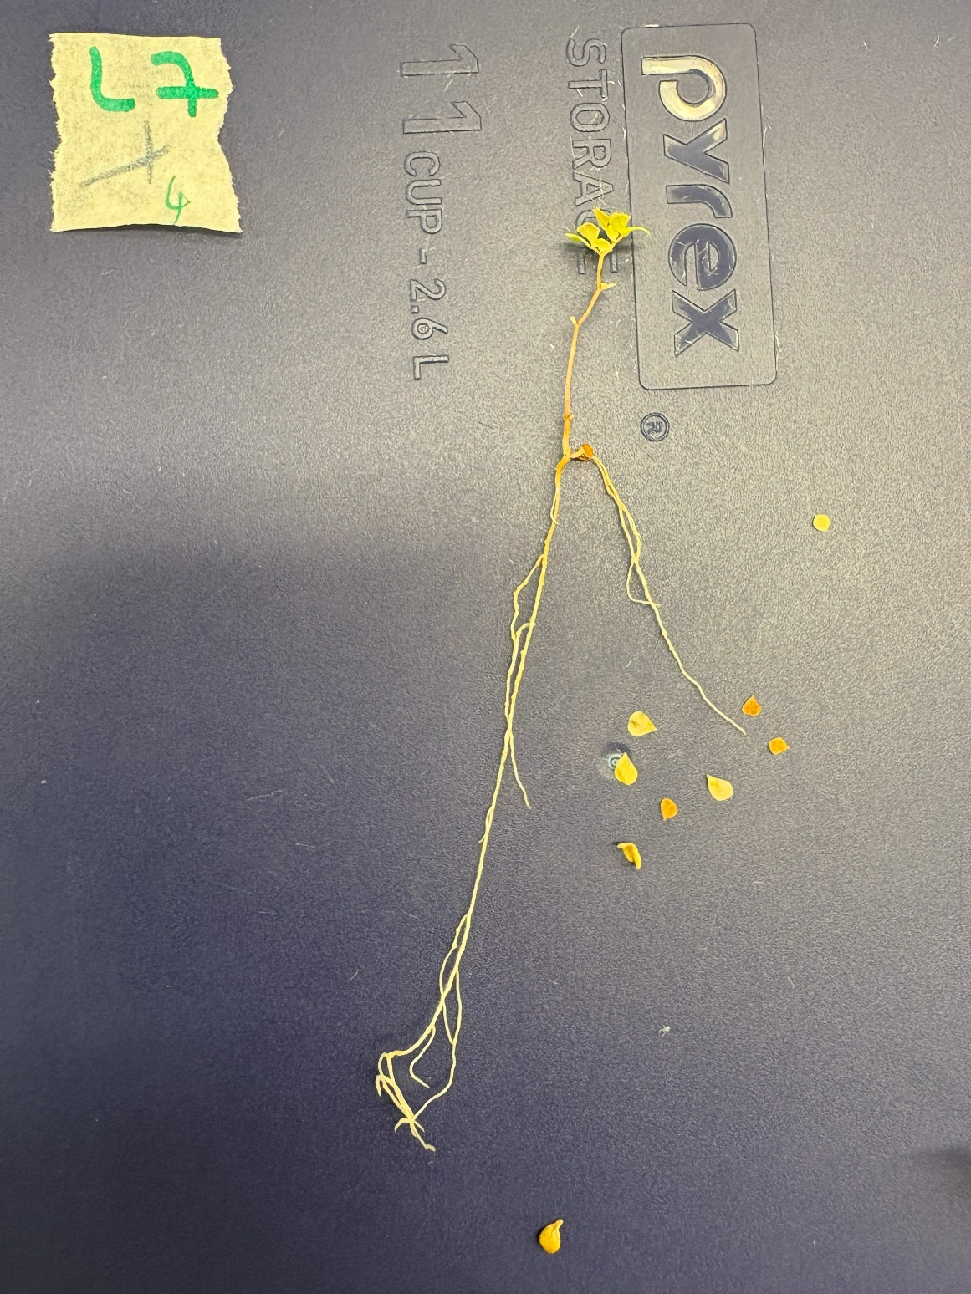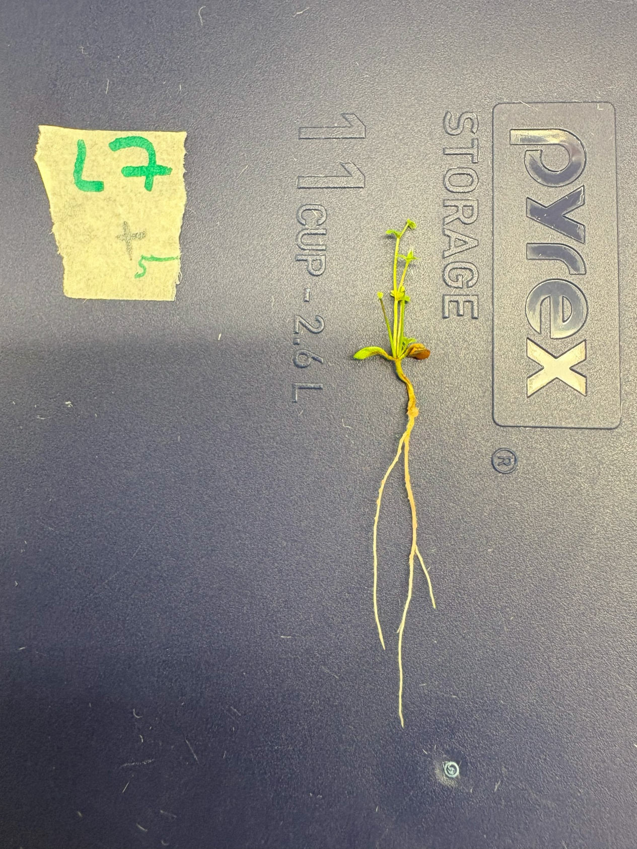

**Weight Assay One-Way ANOVA assumption plots**

**Supplementary Figure 4.** Plots referenced to ensure the dry foliage weight data meets the necessary assumptions for a One-Way ANOVA. **a)** Plot of fitted values against residuals to assess homogeneity of variance. The reasonably flat fitted line indicates that the residuals are reasonably equal between groups **b)** a Normal Q-Q plot to assess the normality of data. The majority of points are close to the line, suggesting that the data is reasonably normal

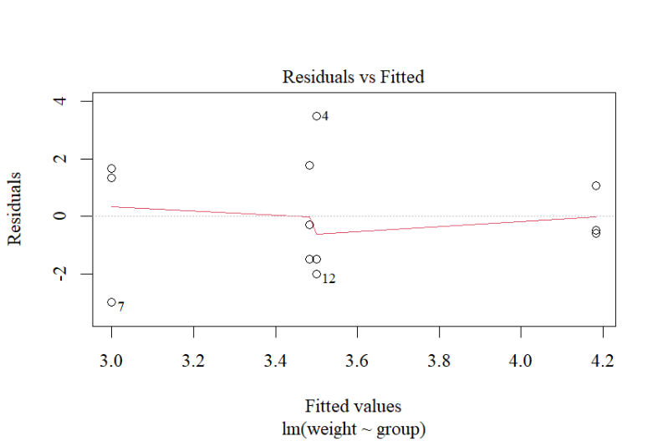

**a)**

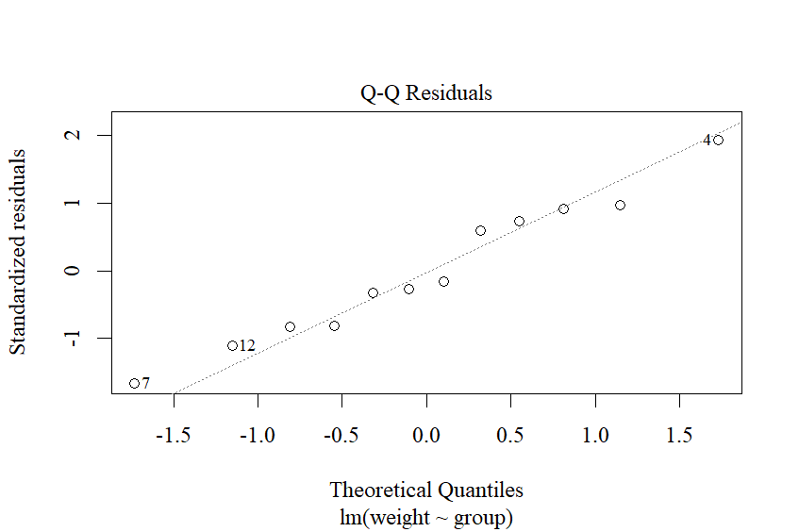

**b)**